**IFT 166 Introduction to Internet Networking**

**Lab 15  
Router Address Configuration**

For all parts of the lab, assume all switches are layer 2 switches (unmanaged switches)

**Part A: IP Configuration**

For each of the computers A, B, C, D and E assign an IP address, a subnet mask, and a default gateway.  
  
By understanding the Router’s IP address and Subnet Mask, you should be able to configure the PCs on the networks. A PC can sometimes can get their configuration details from multiple routers.

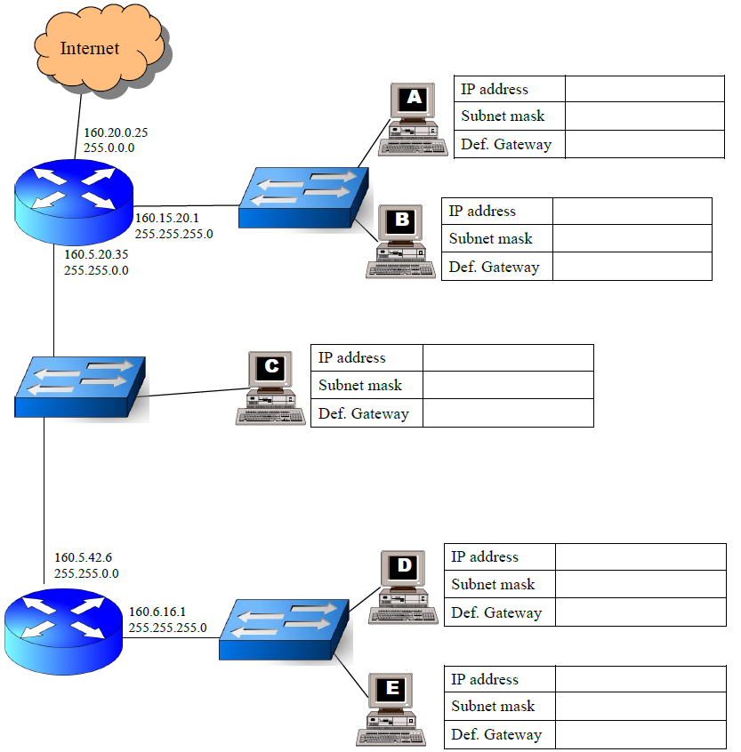

|  |  |
| --- | --- |
| PC-A | IP ADDRESS – 160.15.20.2  SUBNET MASK – 255.255.255.0  DEFAULT GATEWAY – 160.15.20.1 |
| PC-B | IP ADDRESS – 160.15.20.3  SUBNET MASK – 255.255.255.0  DEFAULT GATEWAY – 160.15.20.1 |
| PC-C | IP ADDRESS – 160.15.0.1 – 160.15.255.254  SUBNET MASK – 255.255.0.0  DEFAULT GATEAY – 160.5.20.35 |
| PC-D | IP ADDRESS – 160.6.16.2  SUBNET MASK – 255.255.255.0  DEFAULT GATEWAY – 160.6.16.1 |
| PC-E | IP ADDRESS – 160.6.16.3  SUBNET MASK – 255.255.255.0  DEFAULT GATEWAY – 160.6.16.1 |

Assign an IP address, subnet mask, default gateway and DNS server address to Your PC in the following network:

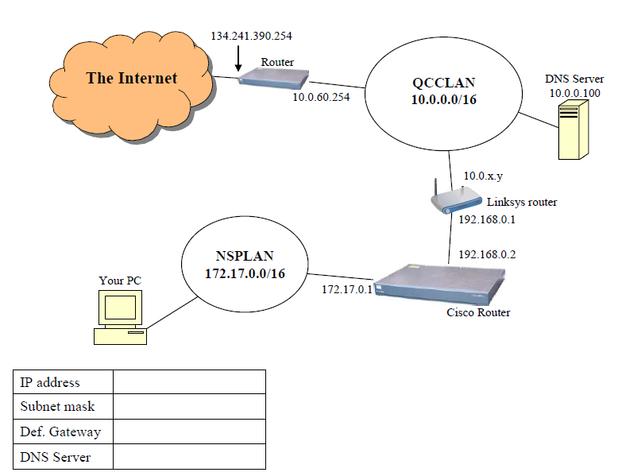

|  |  |
| --- | --- |
| **YOUR PC** | **IP ADDRESS – 172.17.0.2**  **SUBNET MASK – 255.255.0.0**  **DEFAULT GATEWAY – 172.17.0.1**  **DNS SERVER – 10.0.0.100** |

Assign a valid IP address, SM, DG, and DNS server address to PC1, PC2, and PC3 in the following network:

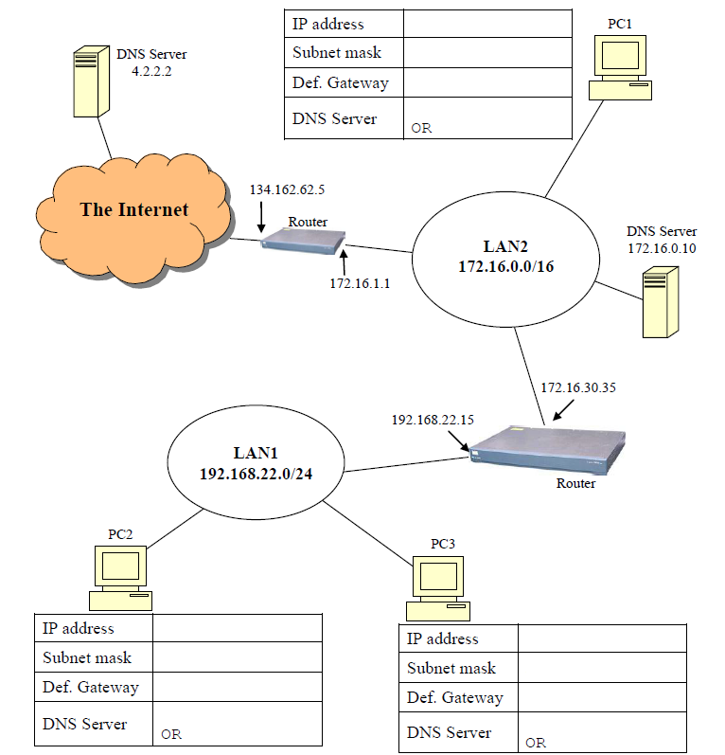

|  |  |
| --- | --- |
| PC-1 | IP ADDRESS – 172.16.1.2  SUBNET MASK – 255.255.0.0  DEFAULT GATEWAY – 172.16.1.1  DNS SERVER – 172.16.0.10 |
| PC-2 | IP ADDRESS – 192.168.22.1  SUBNET MASK – 255.255.255.0  DEFAULT GATEWAY – 192.168.22.15  DNS SERVER – 172.16.0.10 |
| PC-3 | IP ADDRESS – 192.168.22.2  SUBNET MASK – 255.255.255.0  DEFAULT GATEWAY – 192.168.22.15  DNS SERVER – 172.16.0.10 |

For each of the computers A, B, and C, assign an IP address, a subnet mask, and a default gateway.

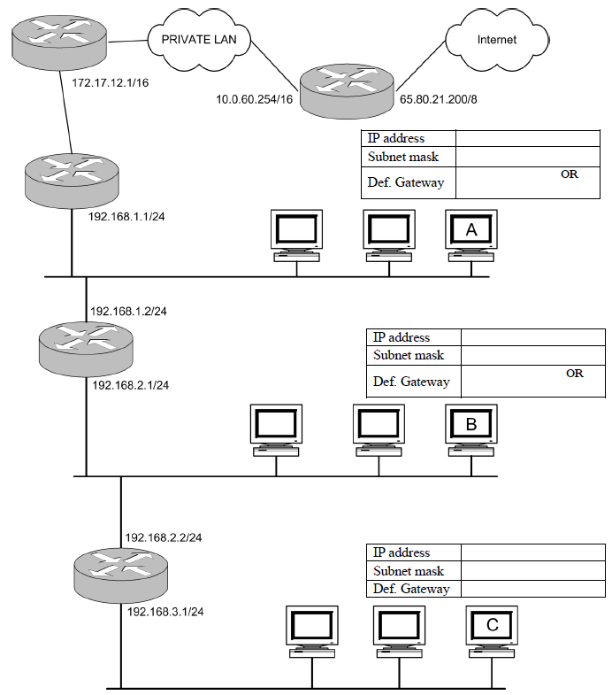

|  |  |
| --- | --- |
| PC-A | IP ADDRESS – 192.168.1.3  SUBNET MASK – 255.255.255.0  DEFAULT GATEWAY – 192.168.1.1 OR 192.168.1.2 |
| PC-B | IP ADDRESS – 192.168.2.3  SUBNET MASK – 255.255.255.0  DEFAULT GATEWAY – 192.168.2.1 OR 192.168.2.2 |
| PC-C | IP ADDRESS – 192.168.3.2  SUBNET MASK – 255.255.255.0  DEFAULT GATEWAY – 192.168.3.1 |

For each of the computers A, B, and C, assign an IP address, a subnet mask, and a default gateway.

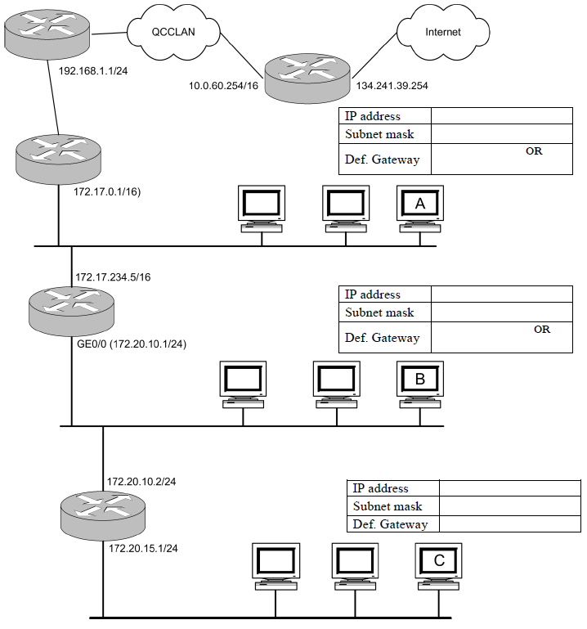

|  |  |
| --- | --- |
| PC-A | IP ADDRESS – 172.17.0.2  SUBNET MASK – 255.255.0.0  DEFAULT GATEWAY 172.17.0.1 OR 172.17.234.5 |
| PC-B | IP ADDRESS – 172.20.10.3  SUBNET MASK – 255.255.255.0  DEFAULT GATEWAY – 172.20.10.1 OR 172.20.10.2 |
| PC-C | IP ADDRESS – 172.20.15.2  SUBNET MASK – 255.255.255.0  DEFAULT GATWAY – 172.20.15.1 |

For each of the computers A, B, C, D, and E assign an IP address, a subnet mask, and a default gateway.

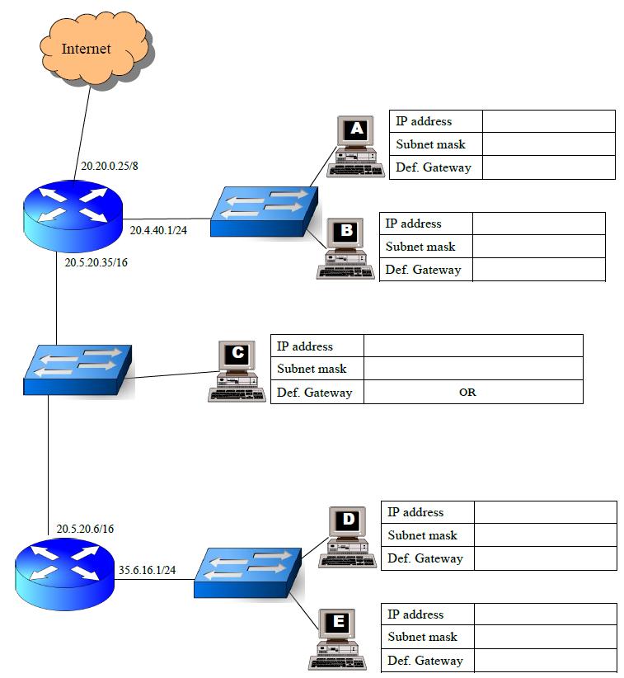

|  |  |
| --- | --- |
| PC-A | IP ADDRESS – 20.4.40.2  SUBNET MASK – 255.255.255.0  DEFAULT GATEWAY – 20.4.40.1 |
| PC-B | IP ADDRESS – 20.4.40.3  SUBNET MASK – 255.255.255.0  DEFAULT GATEWAY – 20.4.40.1 |
| PC-C | IP ADDRESS - 20.5.20.2  SUBNET MASK – 255.255.0.0  DEFAULT GATEWAY – 20.5.20.35 OR 20.5.20.6 |
| PC-D | IP ADDRESS – 35.6.16.2  SUBNET MASK – 255.255.255.0  DEFAULT GATEWAY – 35.6.16.1 |
| PC-E | IP ADDRESS – 35.6.16.3  SUBNET MASK – 255.255.255.0  DEFAULT GATEWAY – 35.6.16.1 |